Step1：Install OBS （IOS or Windows version）
Find OBS studio and double click

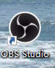

Step 2：
Click settings （设置 in Chinese）

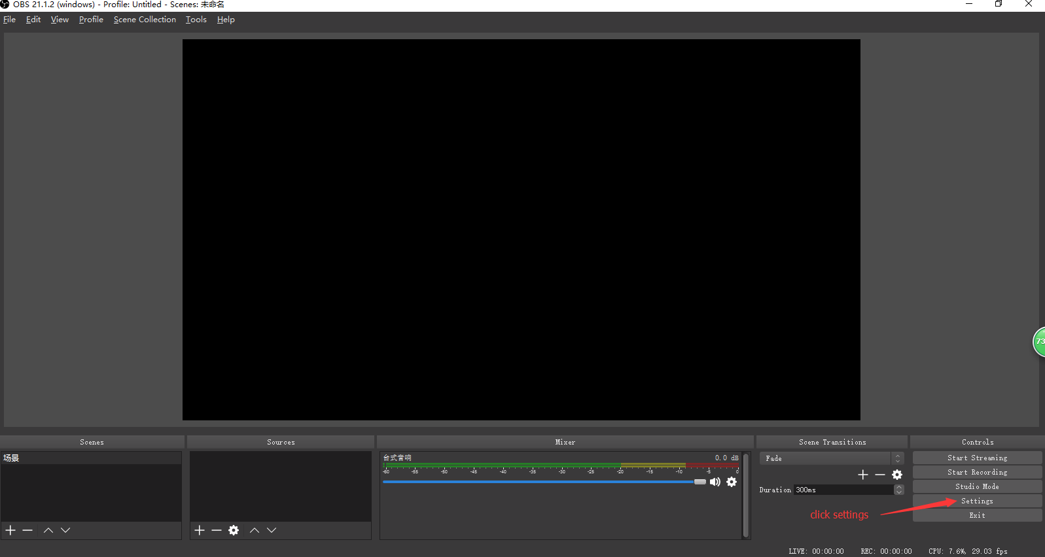
Step 3：
Click General then if the language is Chinese，you can change to English

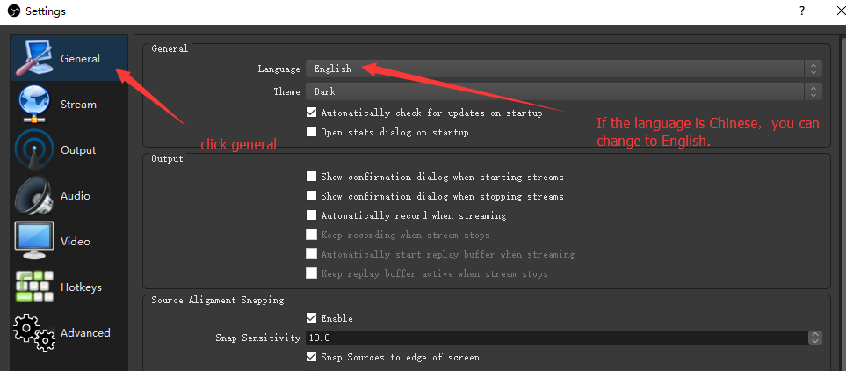

Step 4:
Click video and set up the data.

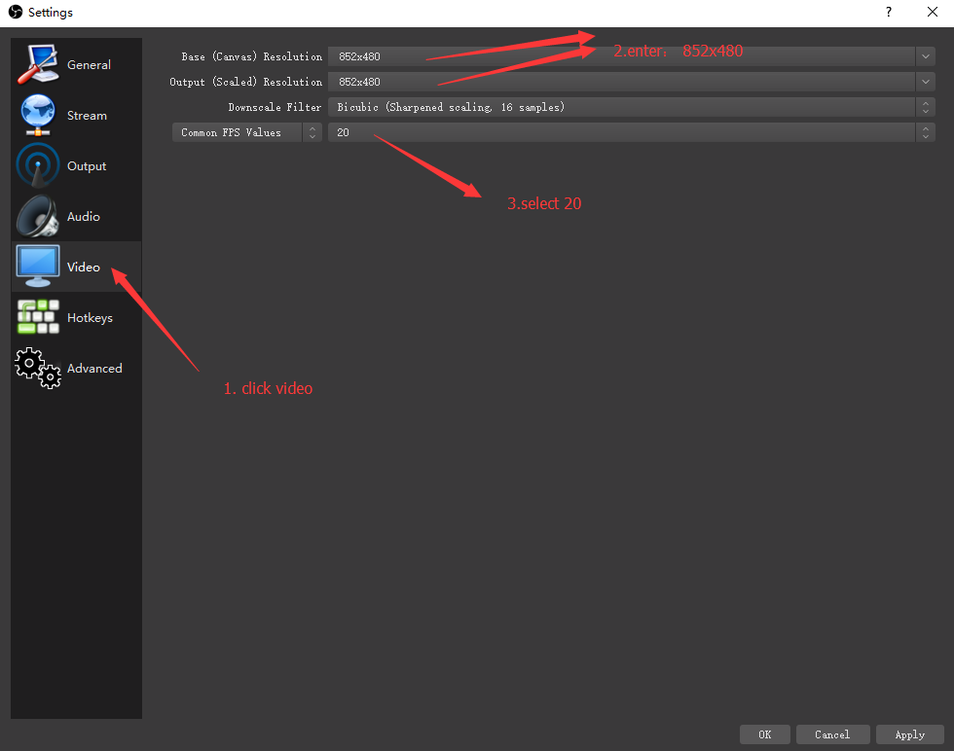

Step 5:
Click stream then set up the data.

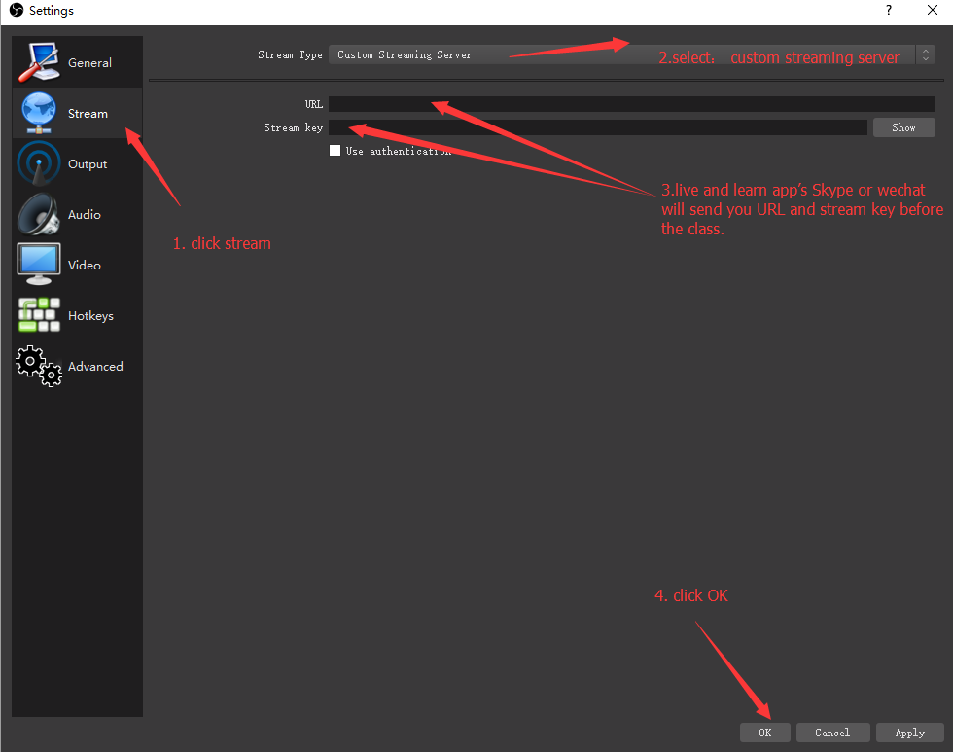

Step 6:
Click +

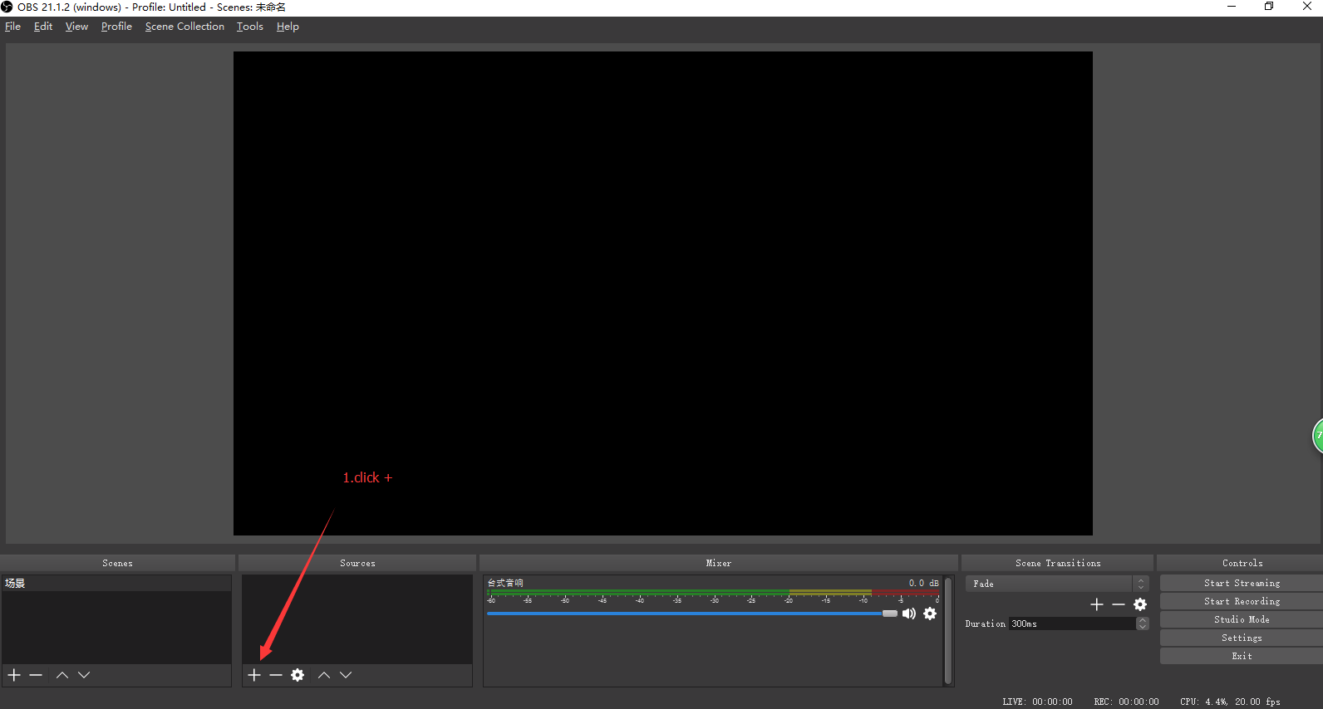

Step 7:
Turn on the camera then Select video capture device and click ok

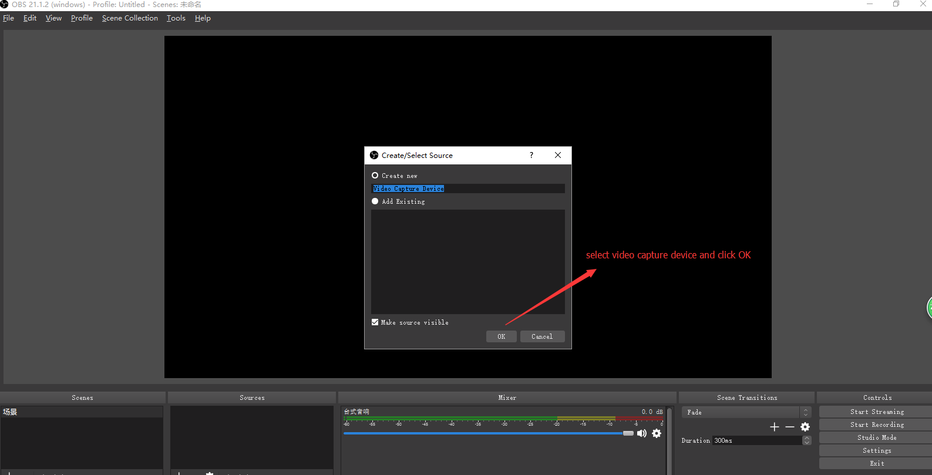

Step 8:
You will see yourself on the screen and click ok.
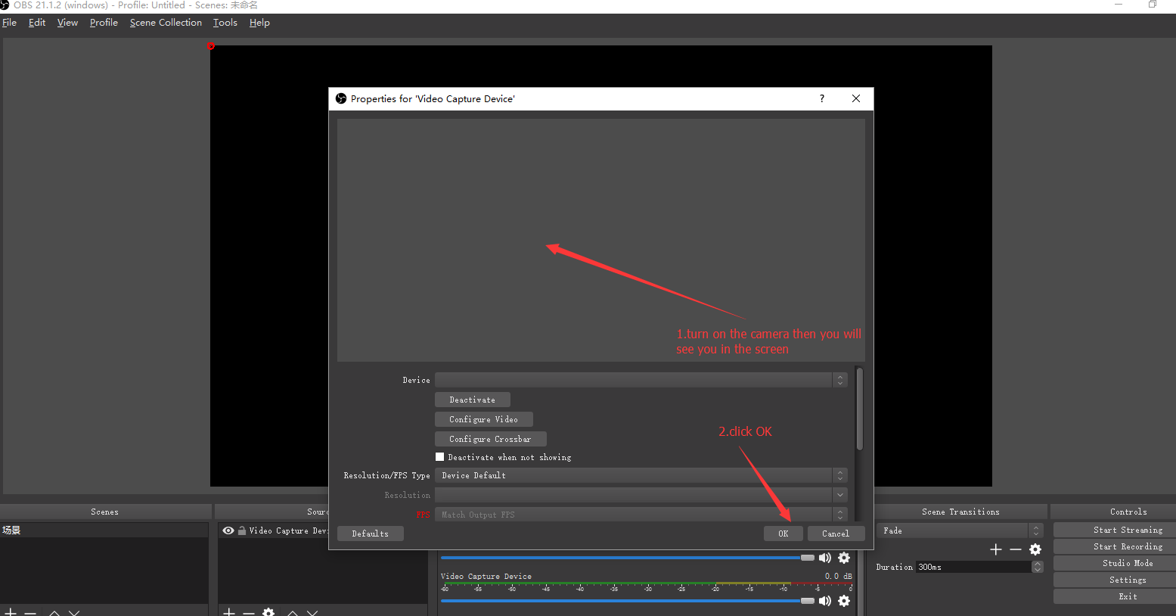

Step 9:
Open the file you are going to teach such as ppt or word or video, Click + then select window capture.

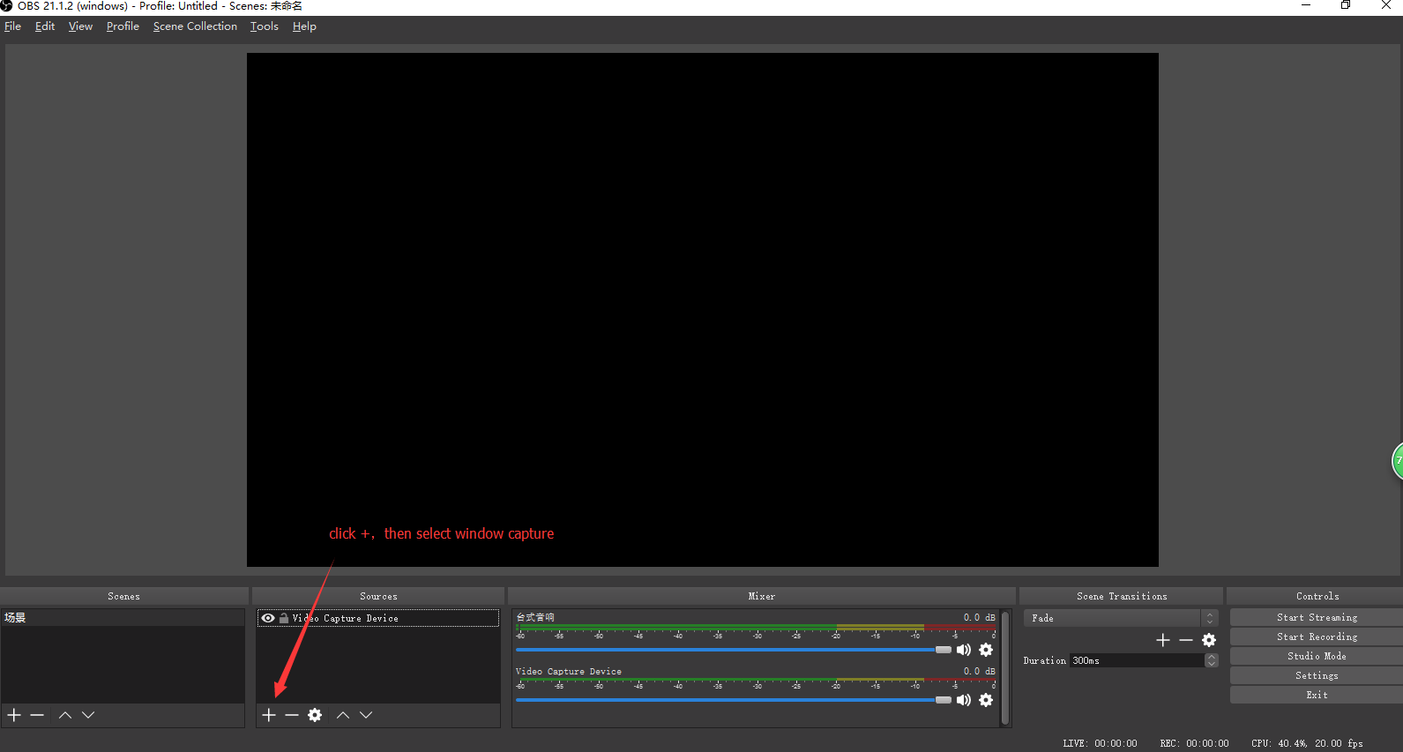

Step 10:
Click ok

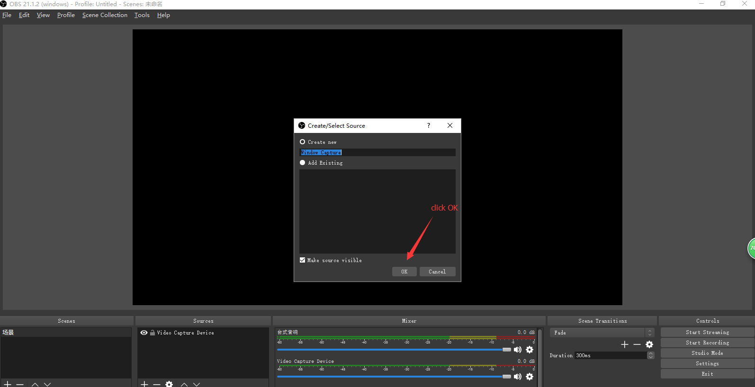

Step 11:
Select the file name then click OK

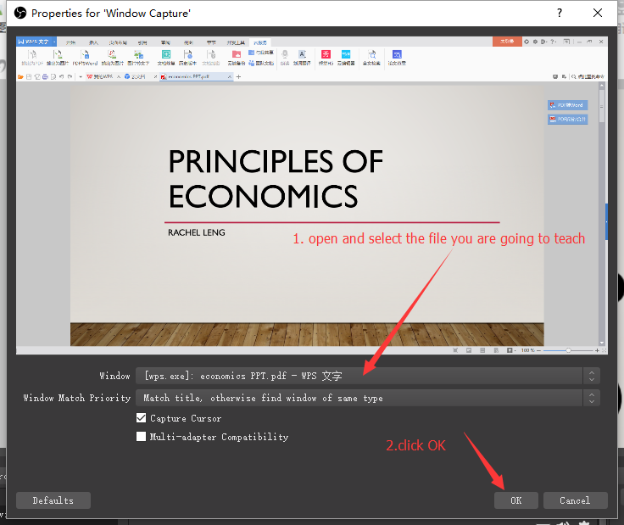

Step 12:
Adjust the file window in the black area.

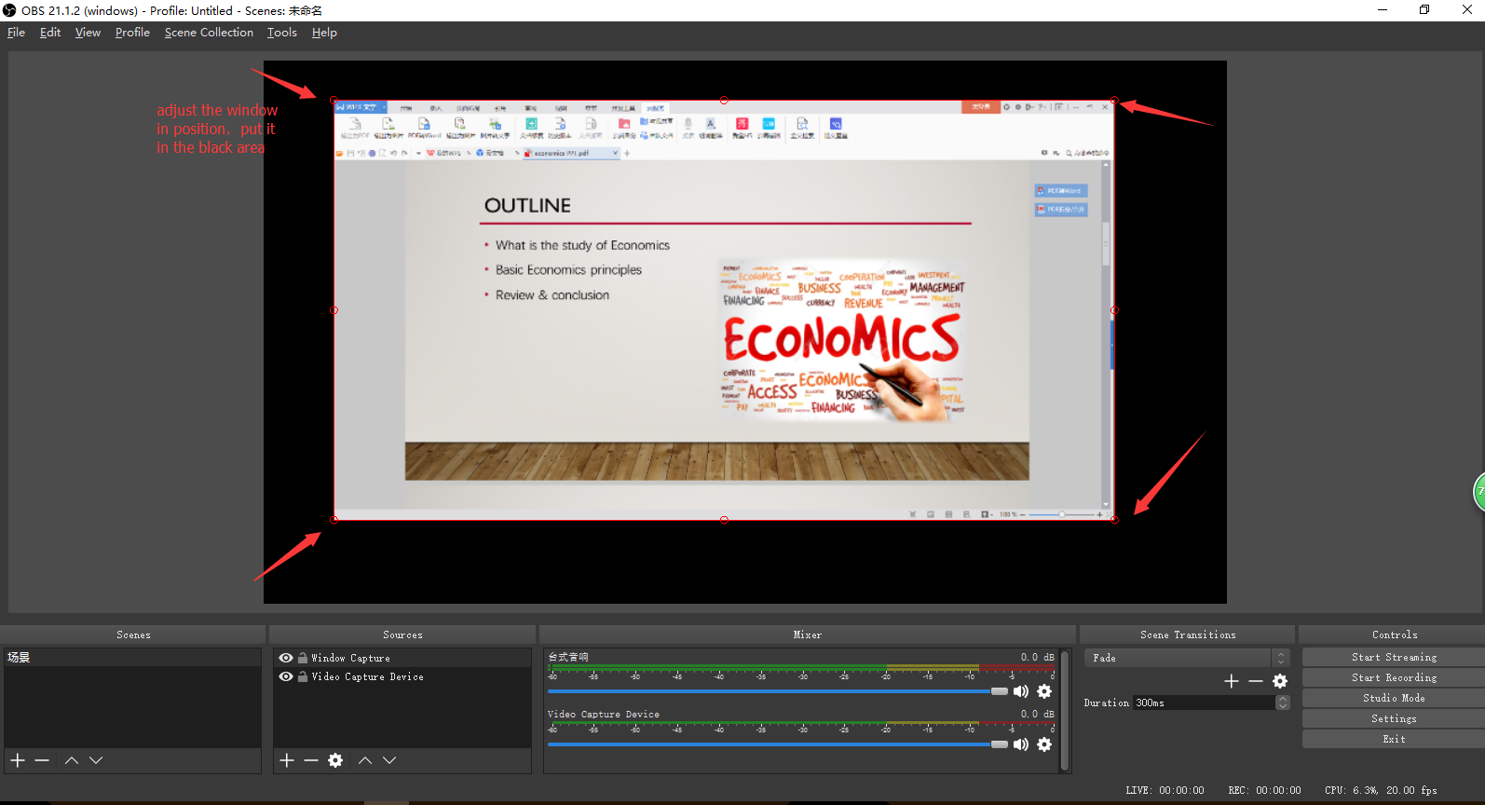

Step 13:
Click start streaming to live class
Or click start recording to record video then send the video to liveandlearnapp@hotmail.com

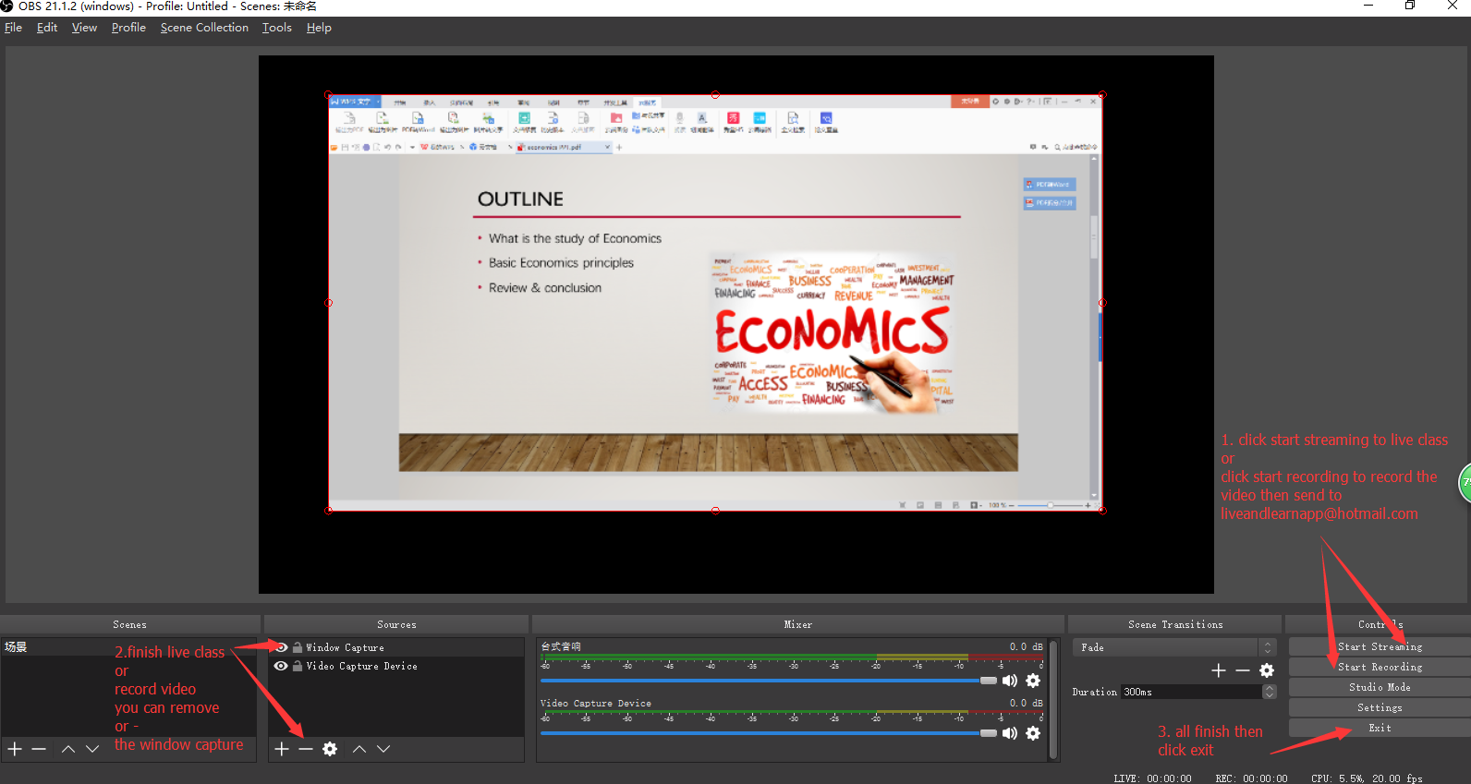

Step 14:

If you want to find the video，click “file”then select “show recording”.
